Economic, Law and Ethics

Cambridge Computer Science Tripos Part IB, Paper 7

Ashwin Ahuja

2019

Table of Contents

Game Theory 2

Strategic Form 2

Prisoners’ Dilemma 2

Hawk-Dove Game 3

Prices and Markets 4

Efficiency 4

Consumer Theory 4

Marginal Rate of Substitution 5

Utility 6

Marginalist Revolution 6

Equilibrium 7

The Business Cycle 8

Trade 9

Externalities 9

Fundamental Theorem (Shapiro, Varian) 10

Network Externalities 10

Asymmetric Information 11

Auctions 12

Strategic Equivalence 12

Revenue Equivalence 12

Combinatorial Auctions 13

Advertising Auctions 13

Principles of Law 13

Criminal Law 13

Civil Law 13

Contract 13

Tort 14

Intellectual Property Rights 14

Computer Evidence Laws 15

General Data Protection Regulation 15

Computer Misuse Act 1990 17

Electronics Communications Act 2000 17

Regulation of Investigatory Powers Act 2000 17

Investigatory Powers Act 2016 17

E-Commerce Law 18

Privacy and Electronic Communications 18

Other Legislation 19

Ethics 19

Philosophies of ethics 19

Current Debates 20

Policy 20

Privacy 20

# Game Theory

**Macroeconomics:** Performance and structure of the global economy or a nation or region. About models of employment, inflation, growth, investment, trade, savings, credit, tax, GNP.

**Microeconomics:** How individuals and firms respond to incentives, how market mechanisms establish prices and the circumstances in which markets fail.

**Game Theory:** Study of problems and cooperation and conflict (two ways of getting what you want) among independent decision-makers. It focuses on games of strategy rather than chance.

1. Games of perfect information
2. Games of imperfect information – often more interesting to analyse

## Strategic Form

Example – matching pennies. A and B throw H or T. If they’re different, A gets Bob’s penny;

otherwise he gets hers. Strategic form is:

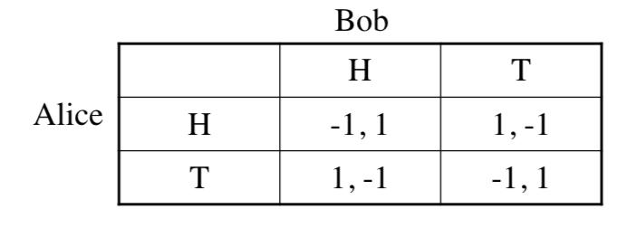

This is an example of a zero-sum game – one players gain is the other’s loss

**Strategy:** Algorithm of input state to output play

**Dominant Strategy Equilibrium:** When each player’s optimal play is a constant, irrelevant of the other’s play.

**Nash Equilibrium:** When each player’s strategy depends on what they think the other will do. Strategies are in Nash equilibrium when one’s choice is optimal given the other’s and vice versa.

**Pure vs Mixed Strategies:** Some games have no Nash equilibrium – the fix is a randomised algorithm – this is a **mixed strategy.** A deterministic algorithm is called a **pure strategy**

## Prisoners’ Dilemma

Two prisoners are arrested on suspicion of planning a robber. Police tells them separately: if neither confesses, one year each for gun possession, if one confesses he goes free and the other gets 6 years. If both confesses, then each will get 3 years.

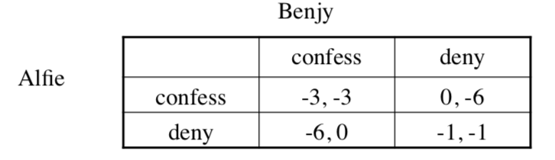

(confess, confess) is the dominant strategy equilibrium – this is clearly not optimal for the villains. Both will cheat rather than cooperate, with a bad outcome.

However, if the Prisoners’ Dilemma is played repeatedly, then there’s a fix – cooperate in round 1, then swap for every round. In the presence of noise, tit-for-tat gets locked into (defect, defect) – therefore forgive the other person occasionally

**Price-Fixing:** Competition laws forbit price-fixing cartels, but tit-for-tat behaviour can happen implicitly. Charge a higher amount, and then if the competition competes, then play tit-for-tat

**Stag Hunt:** People can hunt rabbits on their own but must work together to hunt a stag

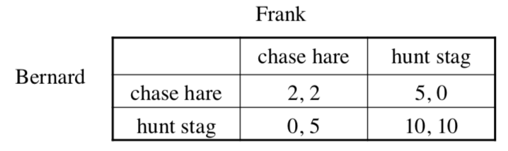

(stag, stag) is Nash equilibrium, however, only chase rabbit if you believe your friend will defect. While PD is payoff-dominant, stag hunt is risk-dominant

**Volunteer’s Dilemma:** Multiplayer game of chicken. If one-person volunteers, everyone else benefits, but if no-one volunteers then everyone suffers a big loss

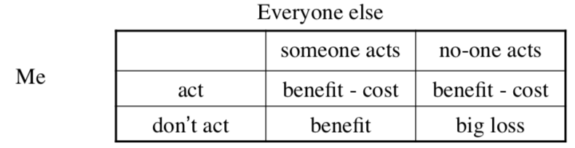

## Hawk-Dove Game

Proposed by John Maynard Smith – mixed population of aggressive and docile individuals. Food v at each round; doves share; hawks take food from doves; doves fight (with risk of death c).

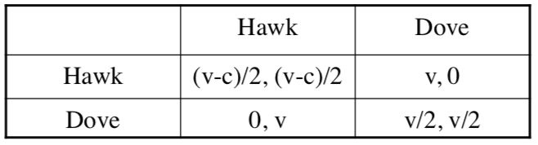

* If v > c, the whole population becomes hawk (dominant strategy)
* If c > v, a small number of hawks prosper as most interactions will be with doves.
* Equilibrium reached at hawk probability p setting hawk payoff = dove payoff

**Implications**

* Politics: models of conflict and of when religions are dominated by fundamentalists
* Criminologists: model Mafia as alternative contract enforcement, and tattoos as signalling
* Evolutionary basis of morality: fairness from tit-for-tat, hierarchy from hawk-dove
* Cooperation developed by states, religions, literature, markets, rights, TV
* Necessity of cooperation – what happens if social cooperation institutions are replaced by online mechanism
  1. Spread of broadband was correlated with a rise in political polarisation

# Prices and Markets

**Accommodation Market:** 1000 flats to rent and people vary in willingness / ability to pay

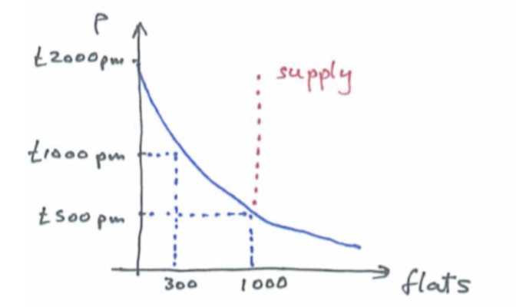

**Market Equilibrium Price** is price where the supply and demand curves cross.

Can however, make more money by selling, for example 800 flats at £700ppm than 1000 at £500ppm. This is an inefficiency.

## Efficiency

A monopolist leaves some flats empty despite people being prepared to pay for them:

* **Pareto improvement** – way to make some people better off without making anyone worse off
* **Pareto efficient allocation** – no Pareto improvement is possible

This is clearly weak though – for example, pure monarchy and pure communism are both Pareto efficient.

**Discriminating monopolist:** If you know what everyone can pay, charge them that – this is Pareto efficient. The monopolist captures the consumer surplus – the total amount people saved on their reservation price.

**Monopoly and Technology:** Monopolies are common in the information goods and services industries – hence many prices of software.

## Consumer Theory

Examines mechanisms of choice. Consumers choose the best bundle of goods they can afford. We assume a budged constraint m, st. p1x1 + p2x2 ≤ m – this gives us a line upon which our choices must lie.

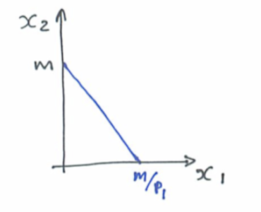

**Indifference Curves (isoquants)**

Join mutually indifferent points – that is where the consumer prefers bundle (x1, x2) equally to (y1, y2). We assume they are well behaved – the curves don’t cross.

**The weak axiom of revealed preference:** Consumers pick the best curve that is affordable

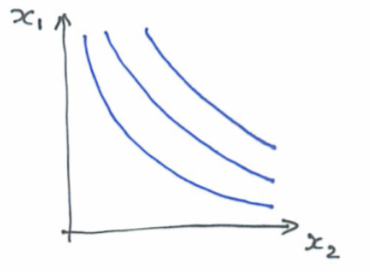

**Substitutes:** Don’t care about whether you have a good 1 or 2.

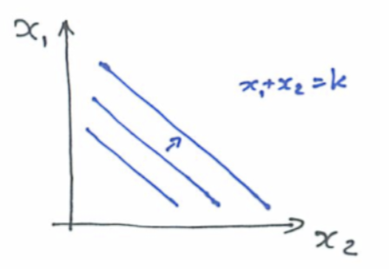

**Complements:** Want exactly the same quantity of good 1 and good 2

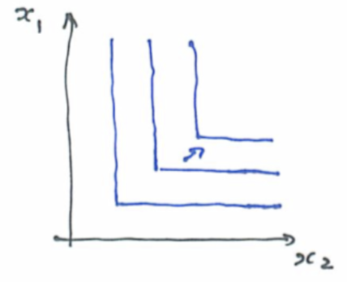

**Bads:** Goods that rather avoid – but sometimes have to consume some of a bad in order to enjoy some of a good

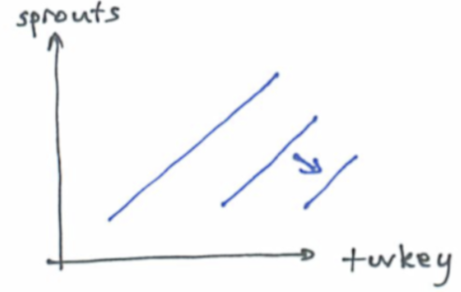

## Marginal Rate of Substitution

Tangent to isoquant gives the marginal rate of substation – exchange rate at which the consumer will trade with the two

Therefore, convex curves means you’re more likely to trade the good if you have more of it – however, the more you have of x1 relative to x2, the more likely you are to trade x1 for x2 in the strictly convex case – **diminishing MRS**

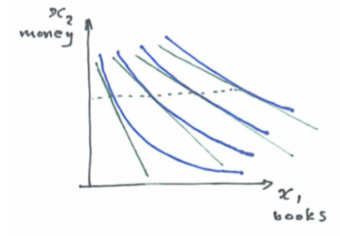

## Utility

Indifference curves can be parametrised – MU1 = dU/dx1. Then MRS = -MU1 / MU2

Utility functions can be useful for describing consumer choices – can often be inferred from shopping behaviours, and answer questions about the value of better / faster / …

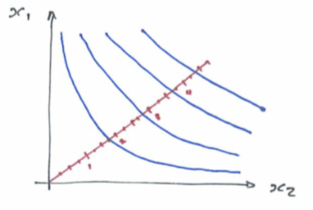

**Cobb-Douglass Utility**

U(x1, x2) = x1c x2d – if the utility is believed to depend on a number of observed factors, take logarithms and look for fit.

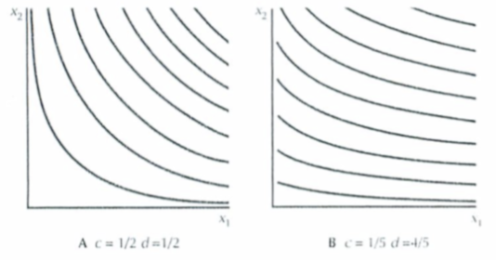

## Marginalist Revolution

**Karl Menger, Stanley Jevons, 1871:** The value of a last and least wanted addition to your consumption of a good defines its value to you – explains why essentials are cheap, while luxuries are more expensive

**Demand:** Can get consumer’s demand from their utility or vice versa. Market demand is the sum of demand over suppliers.

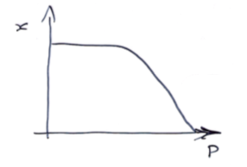

* **Elasticity:** Measures the effect on demand of a small change in price
  + 
  + Elasticity of 1 means there are substitutes
  + Price increases boost revenue iff |ε(p)| < 1
* **Revenue = pq =** q (1 - |ε(p)|)
* **Supply**
  + Firms typically have fixed costs and variable costs, so the average cost of goods initially falls with output.
  + Variable costs typically rise at some point (overtime) and eventually rise sharply due to capacity constraints

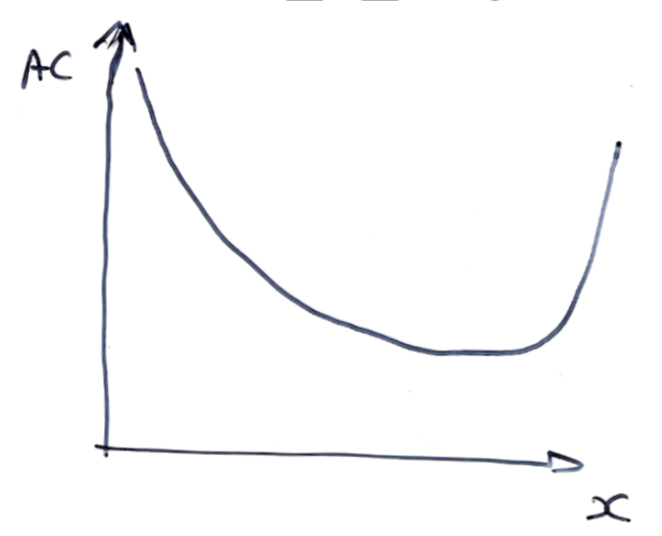

* + Over time, firms fix capacity constraints by building more factories

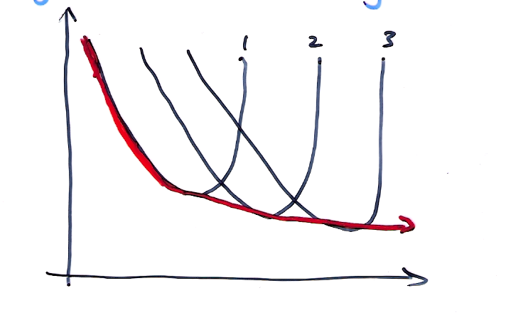

* + In information goods and services industries, marginal costs never rise – so firms have increasing returns to scale
  + **Firm Supply**
    - In competitive market, firms are price takers

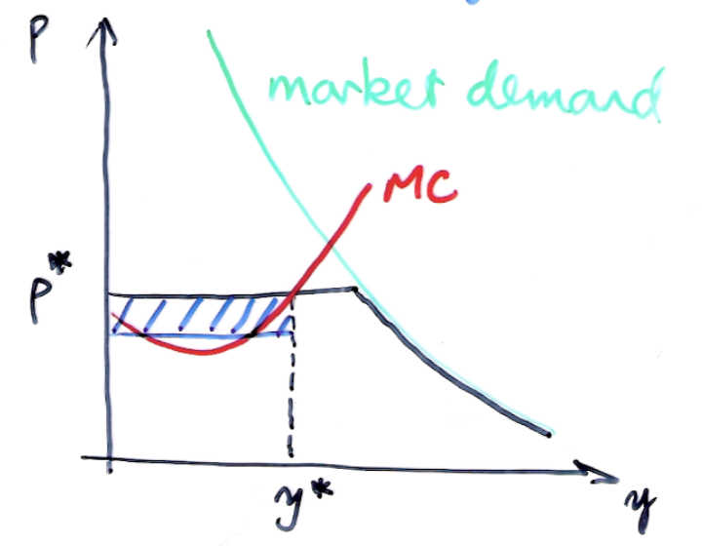

* + - Demand curve faced by each firm – black
    - At any price above p*, demand is zero
    - At any price below p*, the firm would face all the demand
    - Firm’s profit is maximised when it sets output so that its marginal cost equals price p*
  + Prices are set where supply and demand intersect in competitive markets
  + Intrinsic advantages of non-marginal suppliers get built into rental values

## Equilibrium

**Partial Equilibrium Analysis:** Studying supply and demand for one good is

**General Equilibrium Analysis**: Adds in labour, capital, etc

**Theorems**

1. Market equilibrium is Pareto optimal
2. Any Pareto optimal allocation can be achieved by market forces provided preferences are convex

**Efficiency, Welfare and Justice**

Efficiency does not imply justice

* W = ∑ Ui is classical utilitarian welfare
* W = min Ui is Rawlsian welfare – that of the most miserable citizen

**Pigou:** diminishing marginal utility of money means that transferring £1 from a rich man to a poor one will generally increase welfare

**Arrow’s Impossibility Theorem:** There is no perfect way to aggregate personal choices into social welfare that’s consistent with democracy

**Income Distribution:** Gini coefficient is used to measure inequality

* Gini = A / (A+B) where B Is the cumulative income distribution

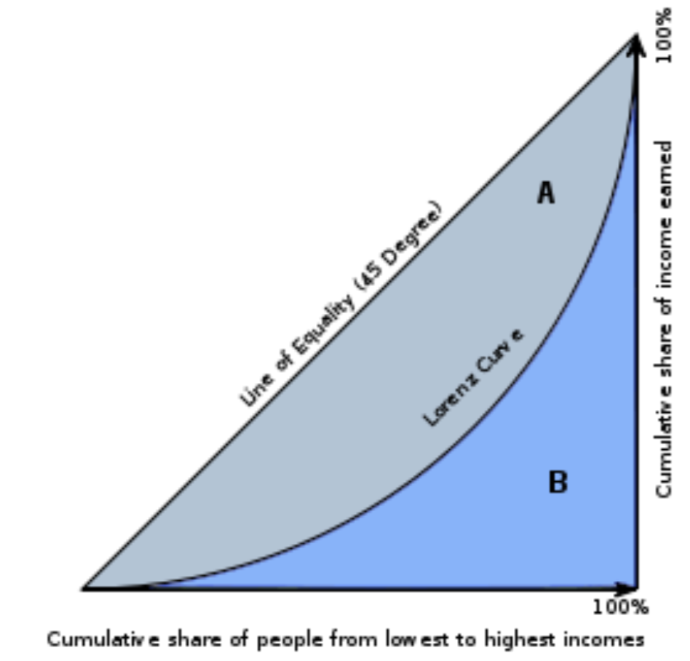

* Gini = 0: communism
* Gini = 1: king has everything
* Gini falls with development – explained by conflict theory

# The Business Cycle

**Say’s Law:** Supply and demand are equal

**Mill and Ricardo** argued that demand for goods and savings = supply of goods and investment, and savings = investment, so demand = supply

**Liquidity Preference:** People want a certain level of savings (eg 3 months’ salary). In a recession, liquidity preference rises.

In a boom, people and firms borrow assets that appreciate faster than the interest they pay. In a recession, many bad things happen at once:

* Loans go bad
* Bank’s share price falls, further eating into capital
* Regulator raises capital requirement from 6% to 8%
* The government competes for the available loans
* => money supply could contract sharply
  + Government did quantitative easing to try and fix this

**Recession and Tech:**

Great Recession kicked off by US mortgage crisis of 2007 which led to collapse of money markets. Recessions may be fed by bubbles bursting but are often tied up with technology change: railways 1840s, electricity 1880s, cars 1920s, tech now – boom creates capacity, bust slashes industry. **Shumpeter: creative destruction**

# Trade

**Adam Smith “Wealth of Nations” (1776):** If a foreign country can supply us with a commodity cheaper than we ourselves can make it, better buy if off them with some part of the produce of our own industry, employed in a way in which we have some advantage.

**Ricardo, 1817:** it’s comparative advantage that matters

**Example**

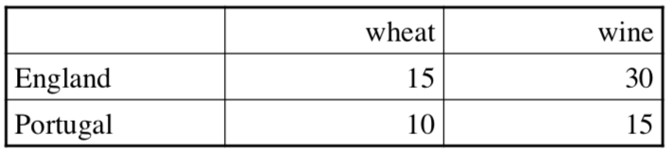

Portugal has an absolute advantage at producing both wheat and wine, but England has a comparative advantage in wheat – each unit costs ½ unit of wine versus Portugal’s cost 2/3 a unit of wine

**Mill**: welfare gains from trade come from cheap imports

**Hecksher-Olin model**: capital vs labour (outsourcing)

Under perfect competition, free trade is optimal, almost all economists agree it’s also a pragmatic optimum; but there can still be losers

**Growth**

* Adam Smith: output = f(land, labour, capital) so growth means land improvement / colonisation, education / specialisation, capital accumulation
* Keynes: it’s all about capital formation
* Neoclassical: it’s all about technology and population growth
* Modern view (Becker, Romer): mostly know-how
* Chad Jones: US growth 1950-1953 due 50% to worldwide R&D, 30% better education, 20% to population growth in idea-producing countries
* Prescription: spend four times as much on R&D

# Externalities

Tragedy of the Commons: 100 peasants graze a sheep on the common. If one peasant adds one more, he gets 100% more, while the others get 1% less. This leads to overgrazing – this phenomenon is used to justify **enclosure movement**

Externalities are goods / bads that people care about but are not traded: these are typically side-effects

* In the presence of externalities, competitive equilibria are unlikely to be Pareto efficient
* This could be fixed with property rights, but this is hard with many players, or delays

**Public Goods:** Non-rivalrous and non-excludable – opposite is true for a public bad. Since the bad is divided between everyone, there is a temptation for people to free-ride.

**Club Goods:** Traditional communities can simply limit scale. This is self-enforcing – people enforce the rules on each other for the good of the entire group. This is effectively politics!

**Politics:** Structure of complex exchange among individuals, a structure within which persons seek to secure collectively their own privately defined objectives that cannot be efficiently secured through simple market exchanges (Buchanan)

**Monopoly Rents:** absent barriers to entry, firms will enter a market until excess profits competed away. Regulating prices doesn’t really work – NY taxi driver example where increasing prices simply helped the license owners. Economists define a rent as an excess undeserved income resulting from barriers to competition – rent seeking drives lots of politics.

**Information**: Marginal cost of producing information is zero, so this is the market clearing price

**Lock-in:** Often, buying a product (service) commits you to buying more of it or spending money on:

1. Durable complementary assets
2. Skills
3. Services

## Fundamental Theorem (Shapiro, Varian)

The net present value of your customer base is the total cost of switching (including hassle cost). Therefore, the incumbent will strive to maximise switching costs, while the competitors to minimise them – **asymmetric switching costs**

## Network Externalities

* Networks become more valuable to each user the more people use them
* **Metcalfe’s Law:** the value of a network is proportional to the square of the number of users
* True networks as well as virtual networks
* Markets with network effects can ‘tip’

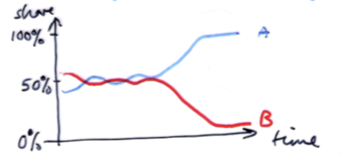

**Strategic Issues:**

* Each of the factors – high fixed costs plus low marginal costs, significant switching costs due to technical lock-in and network externalities tends to lead to a dominant-firm market model – monopoly is even more likely!
* **Ethics**: how bad are monopolies
* **Policy**: do you hope that incumbents become obsolete or do you regulate?
* **EU Law:** fairly-won monopoly is OK, but using dominance in one field to get it in another is illegal

**Price Discrimination:** An efficient monopolist sells to each customer at their reservation price. Pigou created three degrees of price discrimination:

1. Personalised pricing: haggling, loyalty cards
2. Versioning: first / economy class
3. Group pricing: student and OAP discounts
4. *Bundling – not in Pigou’s three degrees!*
   1. Sell a number of products together
5. *Subscription model*

# Asymmetric Information

**Signalling Theory:** Idea that you can use a signal as a proxy for some kind of hidden information – eg university as a proxy for quality of education – **adverse selection**

**Moral Hazard:** eg Volvo drivers compensate for safety by driving faster => have more accidents. Insurance markets can be trashed by moral hazard; hence excess, no claims bonus

**Bounded Rationality:** People try to make just-good-enough decisions (Herb Simon - 1950s). Therefore, satisficer will work hard until his lifestyle goals are met, then slack off.

* People are also **hyperbolic discounting** that is, people disregard far-future events
* **Endowment effect:** people generally demand a higher price for something they already own

**Cultural Biases:** Some biases acquired from evolution are modulated by culture – Caliskan notes all MT systems were sexist, racist, homophobic, inhaling prejudice with their training data

**Power of defaults:** Most people simply follow the defaults – leads to **libertarian paternalism –** government make people opt out of some policy options, such as pensions.

**Agency effects:** Classic economics sees institutions as rational – but decisions are made by individual managers, who optimise their own utility as well.

* **New institutional economics**: idea of studying managers behaviour – leads to giving shares to people
* **Public-choice economics:** apply incentive analysis to civil servants and elected politicians and it doesn’t really work as well.

**Transaction Costs:**

* Trades are not free – takes time and effort
* **Ronald Coase (1937):** why do some sectors have large companies, and others small ones? External transaction costs are higher than internal ones
* **Jensen-Mockling (1976):** agency costs within firms also matter hugely
* **Oliver Williamson (1980s to 90s):** incomplete contracts: frequency, specificity, uncertainty, limited rationality, opportunistic behaviour

# Auctions

Around for millennia – standard way of selling livestock, fine art, mineral rights, bonds, etc. Types of auction:

* English (ascending-bid): start at reserve price and raise till a winner is left
* Dutch (descending-bid): start high and cut till somebody bids
* First-price sealed-bid auction: one bid per bidder
* Second-price sealed-bid auction (Vickrey): highest bidder pays and pays second-highest bid
* All-pay auction: everyone pays at every round until one remaining bidder gets the goods

## Strategic Equivalence

* Dutch auction and first-price sealed-bid auction give the same result – the highest bidder gets the goods at his reservation price. Therefore, these are **strategically equivalent**
* Ditto the English auction and second-price sealed-bid auction – but the two pairs are not strategically equivalent
  + In Dutch / first-price auction, you should bid low if you think your valuation is much higher than everyone else’s
  + In second-price auction, it’s best to bid truthfully

## Revenue Equivalence

* Weaker – not who will win, but how much money on average
* According to the revenue equivalence theorem, you get the same revenue from any well-behaved auction under ideal conditions
* Include risk-neutral bidders, no collusion, Pareto efficiency, reserve price, independent valuations
* English, Dutch and all-pay auction have revenue equivalence

What goes wrong with auctions

* (1) In private-value auction, each bidder’s value is exogenous
* (2) In public-value auction, each item has a true price which bidders estimate at v + ε. The buyer is the sucker who overestimated the most.
  + Most real auctions lie somewhere between the two
* (3) Bidding rings – bidders collude to buy low and have a private auction later and split the proceeds
* (4) Early detection / deterrence: an early (1991) ITV franchise auction required bitters to draw up a detailed programming plan. In Midlands and Central Scotland, industry knew there was no competition – therefore bid under 1p per head
* (5) Sniping and other boundary effects
* (6) Risk aversion – if you prefer a certain profit of £1 to a 50% chance of £2, you’ll bid higher at a first-price auction
* (7) Signalling games – show aggression by a price hike
* (8) Budget constraints – if bidders are cash-limited, then all-pay auctions are more profitable
* (9) Externalities between bidders

## Combinatorial Auctions

Externalities lead to preferences for particular bundles of goods: landing slots at airports, spectrum, mineral rights

* Critical application for Computer Science: routing the presence of congestion
* The allocation problem is NP-complete – practical algorithms work up to a few thousand objects

## Advertising Auctions

Basic idea is a second-price auction mechanism but tweaked to optimise platform revenue

* Bidders bid prices pi, platform estimates ad quality ei and then ad rank ai = pi ei
  + Ad quality = relevance x clickthrough_rate
* You pay bit times competitor ad rank / own ad rank
* **Ethical aspects of ad auctions**
  + Ad quality can easily segue into virality
  + If ads are good clickbait and your followers follow them, you pay less

# Principles of Law

**What is law:** Can’t get all we want by private action because of externalities – the main mechanism of getting action is through law

* Criminal: state prosecutes another person
* Civil: A harms B, or breaks a contract with B, so B sues A
* There is significant overlap between the two

## Criminal Law

Crime requires a guilty act (actus reus) and a guilty mind (mens rea) – however, some offences are strict liability. Prosecution must prove the case beyond reasonable doubt

## Civil Law

## Contract

Making the agreements you want

* Consists of an offer and acceptance by competent persons for a lawful purpose involving consideration
* Can be made in writing, orally, by conduct
  + Many national laws require some contracts to be in writing (real estate; insurance guarantees; in the USA, goods over $500)
* **Limits**
  + Consumer Rights Act 2015 extends previous legislation to software
  + Retailer has one chance to repair or replace (at customer’s choice) else refund
  + Can’t enforce unfair contracts against retail customers
  + Can’t exclude liability for death or injury

## Tort

Avoiding infringement of the rights of others, and giving adequate notice to others of your rights that you may want to enforce

* Wrong which unfairly causes someone else to suffer loss or harm – eg negligence, defamation and copyright infringement
* **Negligence:** if you break the duty of care owed by a reasonable person and cause harm directly – usual yardstick is the standard of the industry though some exceptions apply.
* **Defamation:** Libel (if spoken, slander) can be direct defamation, innuendo or linking. This is one occasion where the burden of proof is in the defendant in the UK
  + **Defamation Act 2013** excludes trivial claims, creates public interest defence and makes claimants pursue the author first

**Regulation:** specific things you need to do to enforce your rights or avoid penalties

**Globalisation:** In the case of global company, need to make it clear whose law applies and separately where cases should be heard. A fix for complexity is to specify arbitration of disputes.

**Arbitration:** Contract can specify binding dispute resolution by an arbitrator – can also specify applicable law and set other parameters such as limits on costs.

* Convention on the Recognition and Enforcement of Foreign Arbitral Awards makes awards enforceable everywhere

**Costs:** In the US system, each side pays its own costs but in the UK the loser generally pays the winner’s costs.

## Intellectual Property Rights

In reality, IPR is often a combination of all of the below:

* IT industry strategy: patent portfolios mostly defensive, sued to get access by cross-licensing
* Compound models: GPL linux version, sell windows, charge for support
* Startups: VCs like to see IP

**Patents:** Mechanism to tackle the under-provision of R&D from externality in research

* Protects an invention which must be:
  + (1) Novel
  + (2) Useful
  + (3) Non-obvious
* They generally last 20 years and are generally only physical inventions – software patents in theory are not allowed in Europe
* So far only four CS patents earned serious money

**Trademarks:** Marks capable of distinguishing your goods and services from others. It may be registered (this makes litigation easier). You can sue infringers but have to show a misrepresentation that damages your business.

**Copyright:** Protects literary works (since Statue of Anne in 1709-10) – extending from novels and drama to art, music, software. You don’t need to register it but asserting copyright can make litigation easier. It generally lasts author’s lifetime + 70 years. Protects against copying, etc, but fair use is legal for criticism, parody, education.

* Can avoid competitions about copyright by using better licenses which allow sharing – Creative Commons

**Specialist rights:**

* Database rights (EU only)
* US Semiconductor Chip Protection Act
* Plant breeder’s rights
* Design rights

**Rights based on contract:**

* Materials transfer agreements
* Confidential information, NDAs

**Digital Rights Management:** prevent unauthorized redistribution of digital media – restricts the ways consumers can copy content that they’ve purchased

* US law says it is illegal to mess with DRM mechanisms even when used for technical lock-in
* Lexmark vs SCC case allowed reverse engineering for compatibility
* US Copyright office: legal for repair, but selling tools is illegal
* Open-source tools is a grey area

## Computer Evidence Laws

**Civil Evidence Act 1967:** Ensured that computer records are admissible in civil trials – cannot be described as hearsay.

**Police and Criminal Evidence Act 1984 (PACE):** Required evidence that a machine was working properly. Now repealed and replaced by a presumption that the computer is operating correctly, but if disputed then relying party must demonstrate correct action.

## General Data Protection Regulation

Aim to protect the interests of the data subject – applies to EU firms and to others who process data about people residing in the UK. In particular applies to **controllers** and **processors:**

* **Controllers:** says how and why personal data is processed
* **Processor:** acts on the controller’s behalf

Six principles to be complied with; data must be (extra protection applies for sensitive personal data):

1. Fairly and lawfully processed
2. Processed for limited purposes
3. Adequate, relevant and not excessive
4. Accurate and up to date
5. Not kept in a form that identified people for longer than necessary
6. Processed securely and protected against loss or damage

Requirement to keep internal records of your databases:

* Who you are, the type of data and who provided it
* Retention schedules
* Security arrangements
  + Data minimisation
  + Pseudonymisation
  + Transparency
  + Allowing individuals to monitor processing
* Details of transfers

Must implement appropriate technical and organisation measures that ensure and demonstrate that you comply with GDPR:

* Internal data protection policies
* Staff training
* Internal audits of processing activities
* Reviews of internal HR policies
* Appoint a data protection officer
* Data breaches must be reported to regulator within 72 hours

It is essential to identify why processing is allowed:

1. **Consent:** (1) for each purpose must be freely given, (2) specific, (3) informed and (4) unambiguous – cannot use pre-ticked boxed and infer it
2. **Contract**
3. Legal Compliance

GDPR provides rights for individual:

1. Right to be informed – privacy notice needs to specify
   1. Identity and contact details of the controller and data protection officer
   2. Purpose of the processing and lawful basis for the processing
   3. Legitimate interests of control or third party
   4. Categories of personal data
   5. Any recipient or categories of recipients of the personal data
   6. Details of transfers to third country and safeguards
   7. Retention period
   8. Existence of each of data subject’s rights
   9. Right to withdraw consent
   10. Right to lodge a complaint
   11. Source of the personal data
   12. Whether the provision of personal data is part of a statutory or contractual requirement or obligation and possible consequences of failing to provide the personal data
   13. Existed of automated decision making, significance and the consequences
2. Right of access
3. Right to rectification
4. Right to erasure
5. Right to restrict processing
6. Right to data portability
7. Right to object
8. Rights in relation to automated decision making and profiling

## Computer Misuse Act 1990

* Section 1
  + Unauthorised access to a program or data – important to clearly indicate when access is not authorised
  + Requires knowledge that is unauthorised
  + Need not be a specific machine
* Section 2
  + As with section 1 but done with the intent to commit another serious offense
  + Raises the prison time from 2 years to 5 years – section 1 was 6 months
* Section 3
  + Unauthorised modification – tariff is up to 10 years
  + Intended to make virus writing illegal
  + Amended 2008 to cover DOS as well – making / distributing hacking tool also made illegal – **Budapest Convention**

**Case Law:** Generally, fines have been small, and only about 20 cases a year

1. R vs Bedworth 1991 – got off with an addiction defence (did not have ability to have intent)
2. R vs Pile 1995 – Pile got a custodial sentence – 18 months
3. R vs Lennon – mail bombing (sending 5 million emails to a server) is an s3 offence – got 2 months curfew
4. R vs Whitaker – convicted for not disclosing a time-lock that froze bespoke software when client was late in making payments

## Electronics Communications Act 2000

States that Electronic signatures are admissible in evidence. It also creates power to modify legislation for the purposes of authorising or facilitating the use of electronic communications or electronic storage.

## Regulation of Investigatory Powers Act 2000

Much of Part 1 and IV have been repealed / replaced. Part III tackles encryption and eventually came into force in October 2007.

Can be asked to put seized materials into an intelligible form or provide the key – if you claim the key has been lost, the prosecution must prove otherwise. The keys can also be demanded under special circumstances – notice has to be signed by Chief Constable. This notice must be served under the board level.

## Investigatory Powers Act 2016

Investigatory Powers Act replaces much of the RIP Act 2000:

* Much remains the same, but it legalises lots of things that Snowden revealed

It deals with interception – the idea of revealing content to someone other than the sender and receiver. It also deals with storage of communications data (based on EU directive – this was struck down but then included as part of Investigatory Powers Act) – metadata describing communications and provides for a retention regime. It also permits ‘equipment interference’ (under a warrant) and ‘bulk interception, acquisition, equipment interference’ and collection of ‘bulk personal datasets’

**Interception (tapping phone or copying email):**

* Only be authorised by Secretary of State
* Product is not admissible in court
* GCHQ can scan international communications for factors

**Exceptions**

* Delivered data
* Permission from both sender and receiver
* Stored data that can be accessed by a production order
* Technologists running a network – communications service provider – iff what they’re doing is required for the provision or operation of the service
* **Lawful business practise –** grey area – not very well defined
  + Must make all reasonable efforts to tell all users of system that interception may occur

## E-Commerce Law

**Distance Selling Regulations (2000):**

* Remote seller must identify themselves
* The details of the contract must be delivered (email is sufficient)
* Right to cancel
* Contract VOID if conditions not met

**E-Commerce Directive (2002):**

* Online selling and advertising is subject to UK law if you are established in the UK – whoever you sell to
* Significant complexities if selling to foreign consumers if you specifically marketed to them
* Also provides key immunities for ISPs
  + Hosting, Caching, Mere Conduit

## Privacy and Electronic Communications

**EU Directive 2002/58/EC**

* Has rules on phone directories, location info
* Bans unsolicited marketing communications subject to soft opt-in rules
  + If person has given permission
  + If person has purchased something with the same company and the email is promoting similar product

**ICO Cookie Usage**

* Cookies may be used without permission
  + (1) to make shopping carts work
  + (2) for security purposes
  + (3) for load balancing systems
* Need permission for anything else, including advertising, analytics and personalisation

## Other Legislation

There is lots more legislation to do with **e-commerce** things, including sale of goods, contract law, unfair terms, unsolicited faxes, etc.

Also, adult content rules:

1. Indecent images of children – possession (making, etc) is illegal
2. Extreme pornography – possession (making, etc) is illegal
3. Obscene Publications Act – webmaster of a foreign site was convicted

Other specialist issues:

* Selling age-restricted goods
* TV watersheds
* Fund-raising for political parties

# Ethics

**Practical Ethics:** in what circumstances should we retrain our actions more than the law requires.

## Philosophies of ethics

**Authority theories:** mostly derive from religion

**Intuitionist theories:** we can tell what’s good and bad through intuition

**Egoist theories:** we act rationally in our own interests

**Consequentialist theories:** Maximise the consequence, for example Hume, Bentham and Mill’s utilitarianism: maximise W = ∑Ui (greatest happiness of the greates number)

* How to work out consequences – it is generally hard to define W in a way that is consistent with democracy
* **Act utilitarianism:** action becomes morally right when it produces the greatest good for the greatest number of people
* **Rule utilitarianism:** moral correctness depends on the correctness of the rules that allows it to achieve the greatest good

**John Rawls ‘Theory of Justice’:** moral decisions have to be made on moral decisions about a society behind a veil of ignorance of whether we’ll be born high or low – **maximise W = min Ui**

**Aristotle:** Consequentialist theories are ‘for beasts’ – you’d be happier if you were stupid

* People should act in accordance with nature and duty and they will do good and be happy
* Not just about consequences but about the motives of the actors

**Kantian theory of duty:** act on maxims that you’d like to be universal and treat people as ends not means

## Current Debates

1. Evolutionary Psychology: The moral roots of ethics in the way our brains have evolved
2. Neuroethics: From moral development of children to consciousness as an epiphenomenon
3. Experimental ethics
4. Nature vs Nurture

# Policy

1. **Censorship** – push for technology companies to be censors
2. **Export control** – foreign countries using technology exports
3. **Surveillance**
4. **Privacy**
5. **Freedom of Information –** allow people to access their data
6. **AI**
   1. General problem that AI systems cannot explain their actions

## Privacy

Can’t stop the collection of data (including gestures, speech and images), so have to regulate the use of data – **2014 report on Big Data by US President’s Council of Advisors on Science and Technology**

* For example, ECJ stated that people had right to erase google searches about themselves

**Health Privacy:** David Cameron (2011) – NHS records would be by default be made available for research for transparency. Opt-out required because of European privacy law, and the data had to be anonymised – this doesn’t work for rich linked data

* Hospital Episode Statistics (HES) database has a record of every finished consultant episode in the last 15 years
* 2014: Data was moved offshore to Google cloud – against rules
* 2014: HES data sold to 1200 universities, firms and others
* HES ID leaks postcode, dob in most cases
* 2018: many patients’ optouts ignores

**Dealing with privacy in research:**

1. Ethics based on respect for persons
2. Satisfy human-rights and other applicable law
3. Set reasonable expectations in discussion with people with morally relevant interests
4. Effective and justified systems of governance and accountability